Ethan Allan Extra Large Side

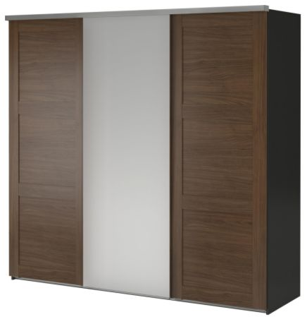

|  |
| --- |
| **DESCRIPTION** |
| Ethan Allen Interior designing has introduced an extra wide multi storage cupboard with center sliding doors and two compartments of press out three chests each. The cupboard has a nice feel with smooth surface and the brown color gives it a natural look which enables it to give a relaxing feeling. Perfect for wide rooms. The new design also gives a brief description about modern life style and walnut touch gives a natural glow. |

|  |  |  |
| --- | --- | --- |
| **Price** | **1300$** | |
| **Dimensions** | **H** x **W** x **L** | **75in x 25in x 62in** |
| **Features** | **It has two compartments of three push out chests each and a central upward sliding door which easily handles the complex design of the cupboard** | |
| **Finished** | **Natural Walnut Cut** | |
| **Available in** | **Silver And Brown Combo** | |